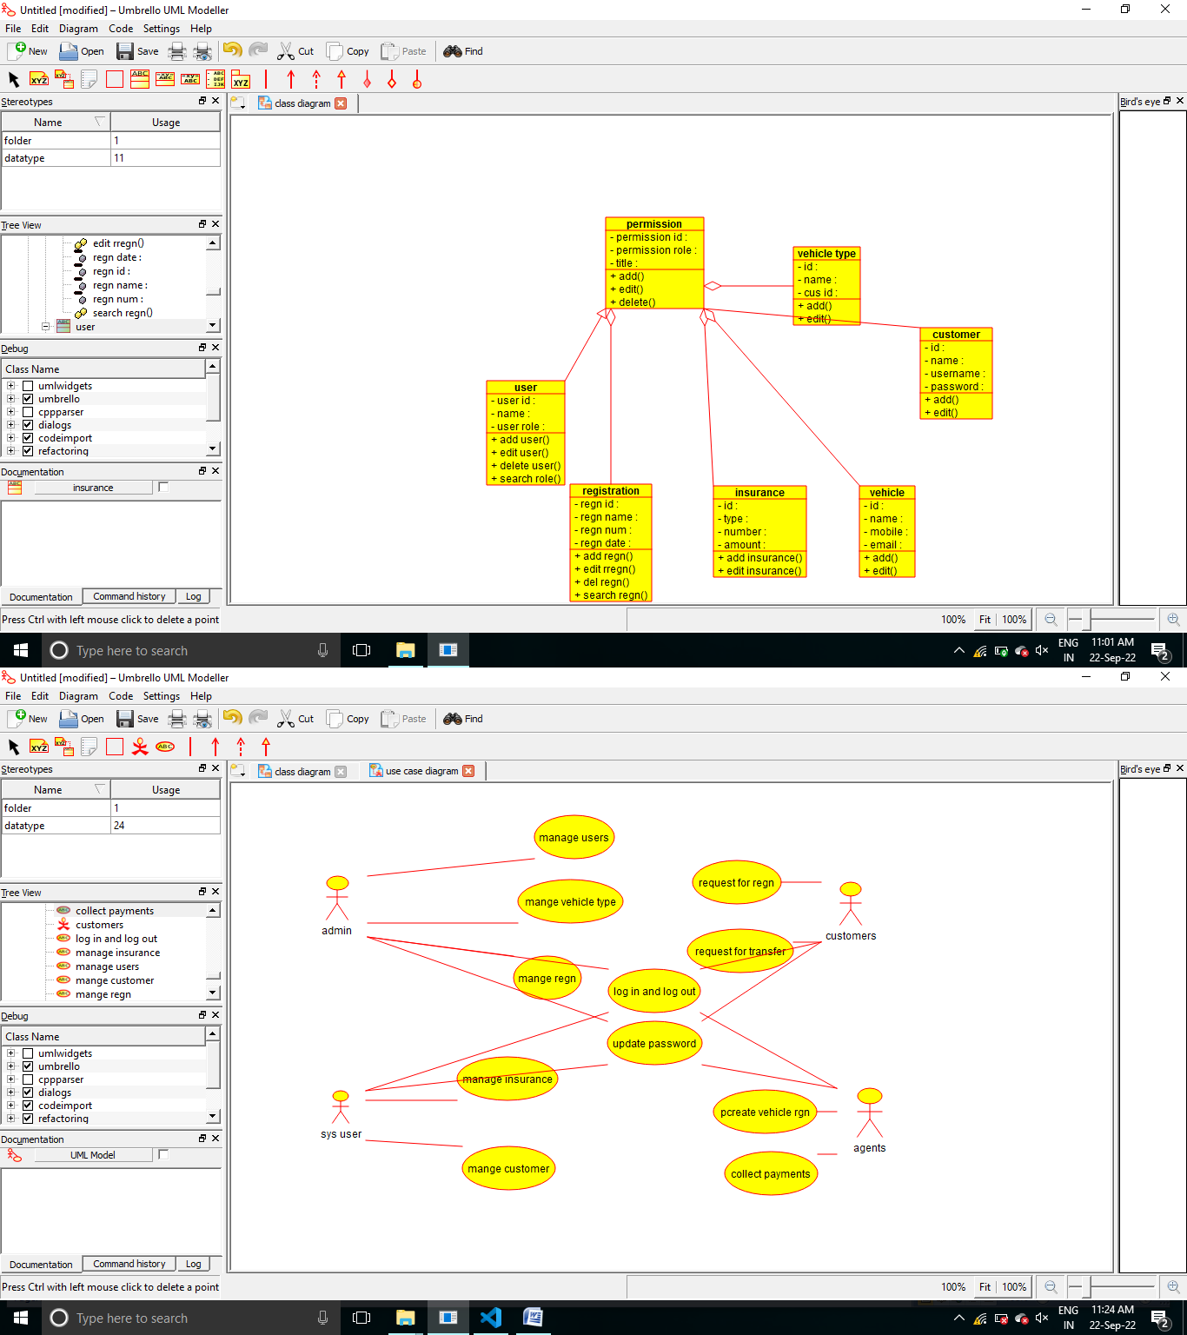

/**

* Class user

*/

public class user extends permission {

//

// Fields

//

private void user_id; private void name; private void user_role;

//

// Constructors

//

public user () { };

//

// Methods

//

//

// Accessor methods

//

/**

* Set the value of user_id
* @param newVar the new value of user_id

*/

private void setUser_id (void newVar) { user_id = newVar;

}

/**

* Get the value of user_id
* @return the value of user_id

*/

private void getUser_id () { return user_id;

}

/**

* Set the value of name
* @param newVar the new value of name

*/

private void setName (void newVar) { name = newVar;

}

/**

* Get the value of name
* @return the value of name

*/

private void getName () { return name;

}

/**

* Set the value of user_role
* @param newVar the new value of user_role

*/

private void setUser_role (void newVar) { user_role = newVar;

}

/**

* Get the value of user_role
* @return the value of user_role

*/

private void getUser_role () { return user_role;

}

//

// Other methods

//

/**

*/

public void add_user()

{

}

/**

*/

public void edit_user()

{

}

/**

*/

public void delete_user()

{

}

/**

*/

public void search_role()

{

}

}